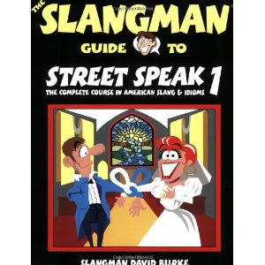
By David Burke: Slangman 1, 2 and 3
Have fun and learn "real" American conversational English!
Our books contain the most common slang and idioms used every day by Americans. Look at this example:
English taught in schools: "I dislike this. It is very difficult."
Real American English: "What a pain!"
Both of them mean the same thing, but "Real English" is the way Americans speak. With our books, you will learn American English conversation using slang and idioms naturally through dialogues, pictures, quizzes, games, etc. You'll be talking like a native "in no time" (very quickly)!

